Future improvements

After weeks of researching and studying our project and its market, thinking thoroughly about what features we could improve in our baby monitor we have come up with some brilliant ideas in which will transform our minor project into the baby-monitor every family will want in their home utilizing Internet of Things to interconnect objects that can collect and transfer data with the aided help of Application Programming Interfaces. In the following document I have listed the ideas in which we believe will not only be future improvements for our project but will be some of the reasons as to why this will be the ideal baby-monitor for every home.

Motorised LED Globe

During our survey that we conducted on several parents and a local crèche it was brought to our attention that there was a want of the parents for colourful reflections in the room or on the ceiling to help soothe the baby. Over 50% of the people who took part in the survey rated the feature of a nightlight either 4 or 5 out of a possible 5.

This will ideally be a globe made from plastic with different shape’s cut from paper which will have a re-adherable strip of glue on its back, similar to a post-it note. These shapes can then be stuck onto the plastic globe and when the LED emits light it will also project a shadow of a shape. This shape can then be changed depending on the child’s likes and interests. This could lead to more scalability opening another market for our device which would then include accessories.

The globe itself will be attached to a motor which will spin at different speed’s depending on the setting chosen by the user. The different speed setting’s will be chosen through our application and will include three different speeds.

A lot of babies when they are growing older can start developing a fear of darkness. Nightlights can help with this, in turn helping them to feel more safe and secure in their bedroom. Our colourful LED’s and shapes will also help in teaching foundational skills to young children, allowing the parents to choose shapes such as numbers and letters. The best age to teach children colours and shapes is between 18-30 months which is a proportion of our target audience. Most children are unable to differentiate between colours until 18 months or so, this is because it is a cognitively complex task for them and as adult’s we sometimes forget this. (Cassidy, 2013) The nightlight can be as equally beneficial to the parents as it allows them to carefully navigate their way through the children’s room for night feeds, or in the case that one of the children in the room that the nightlight is being used in is toilet trained they can safely make their way to the toilet without standing on any dreaded Lego.

The motor that we will be using to rotate our LED globe will be an ordinary DC motor attached to the Arduino. Below I have attached a copy of a 3D concept sketch.



Baby Cot Mobile

Our second idea for developing our project further is to add a mobile feature which will include hanging toys such as animals amongst other favourites. The mobile will use a motor to allow it to rotate slowly at the top of the cot so the child can easily see the shapes moving and can interact with them, it will however be out of the child’s reach so that they cannot harm themselves. The user will be given the choice using our API as to whether they want the mobile to remain static or to slowly rotate. Our mobile provides many similar benefits to our LED Globe including visual stimulation and promotes brain development early on for users.

Cot mobiles are proven to help with baby’s motor skill development at an early age, a baby’s brain is constantly developing and learning new things. Even when laying on its back observing the mobile and toys which are attached to it, a baby is learning spatial awareness as the shapes move closer and further away from it. As the child grows and begins to move a lot more, the mobile will also help with the child’s hand eye co-ordination as it reaches to try and grab the mobile. Over time the child’s accuracy and eye muscle strength will increase when it is trying to point, grasp or hold toys and objects that interest them.

A lot of kids can get quite restless at bedtime, according to a survey that we conducted on parents over 45.5% of parents said that their baby woke at the minimum once a night. The mobile will help with this as their brains will be stimulated if it is a case that they do wake for an unnecessary reason they will fall back to sleep shortly after.(*Will Crib Toys Ruin Your Baby’s Sleep? - The Baby Sleep Site®*, 2014)

The motor that we will be using to rotate our mobile will be an ordinary DC motor which will be attached to the Arduino. Below I have attached a 3D concept sketch I created using windows 10 software.

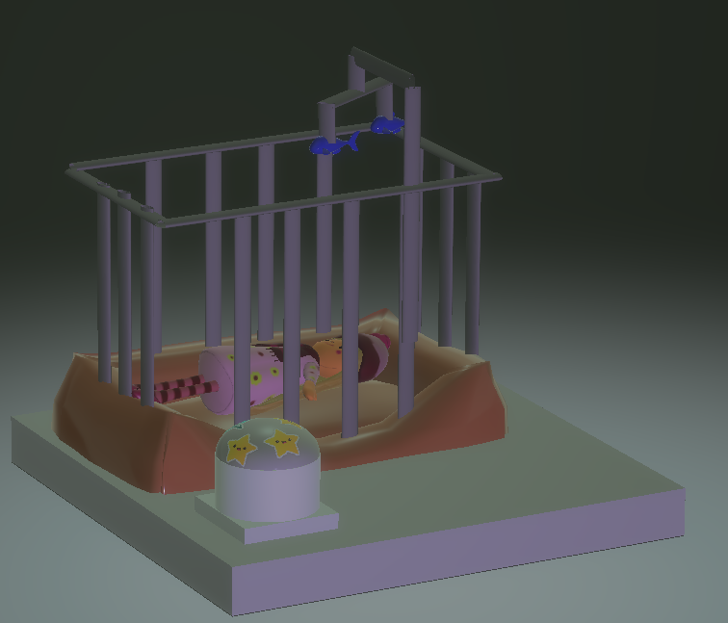

Temperature Sensor

During the research part of our project, we created a survey which we sent out to several parents and a local crèche who were kind enough to take part. Exactly 50% of parents rated the need for a temperature sensor as a feature in the baby monitor in which they would buy for their child’s room 5 out of 5. This information told us that parents would look for the temperature monitor feature as one of the key features that the baby monitor must have, according to our survey this feature was as important to parents as the ability of it to play a lullaby.

The third future improvement which we have decided to add to our project is an added temperature sensor. This sensor will allow the user to monitor the temperature of the baby’s room and if there is a sudden drop or rise in temperature in the room the parents will be alerted on a device of their choice via our downloadable baby monitor application. When setting up the baby monitor app the user will be asked to input what temperature the room is and how sensitive they want the sensor to be to temperature change. For example, in our survey the rooms varied from 12-21 degrees. We also need to allow the user to input how sensitive that they want the monitor to be so if there is a drop in 5 degrees or a rise in 4 degrees for example they will be notified by the monitor. There may also be scope for designing a temperature sensor which will measure not only the temperature of the room but also the baby, further research will have to be made on this topic, but it is a possible of a future improvement. This information could then be connected to the thermostat control using our API. (Jabbar *et al.*, 2019)

The grove temperature sensor that we will be using outputs an analog signal and can detect ranges from -40 to 125 degrees.

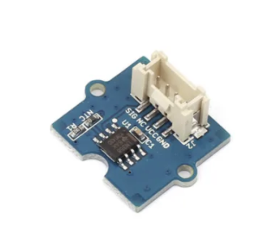

PIR Sensor

The fourth future improvement that we have chosen as a possibility to use in our project is the Passive Infrared Sensor. This sensor utilizes the infrared light radiating from objects in its field of view to detect motion, one of the key elements is that this sensor is passive therefore does not emit any energy that could cause harm to the child. This sensor will be used to detect the baby’s motion and can be set incrementally to avoid unnecessary activation. As a secondary use or benefit for this sensor could be utilized to detect increases of heat generated by electrical devices and predict possible device failure. (Ramesh *et al.*, 2019)

The PIR sensor could be placed at the top of the cot and will detect movement from a 120-degree angle, it also has a measuring range of up to 6 metres. The PIR motion sensor works of a digital port in the Arduino and requires a 3.3/5V supply voltage.

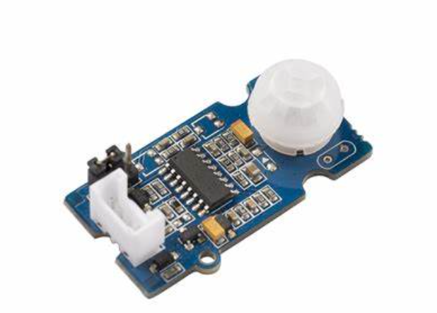

Cassidy (2013) *Discover how to use this guide on when to teach what for your toddler.*, *Teach My Toddlers*. Available at: https://teachmytoddlers.com/when-to-teach-what-a-guide-for-teaching-your-toddler-colors-shapes-letters-and-more/ (Accessed: 12 March 2021).

Jabbar, W. A. *et al.* (2019) ‘IoT-BBMS: Internet of Things-Based Baby Monitoring System for Smart Cradle’, *IEEE Access*, 7, pp. 93791–93805. doi: 10.1109/ACCESS.2019.2928481.

Ramesh, S. *et al.* (2019) ‘A Smart Baby Cradle’, *Global Journal of Computer Science and Technology*. Available at: https://computerresearch.org/index.php/computer/article/view/1815 (Accessed: 14 March 2021).

*Will Crib Toys Ruin Your Baby’s Sleep? - The Baby Sleep Site®* (2014) *The Baby Sleep Site - Baby / Toddler Sleep Consultants*. Available at: https://www.babysleepsite.com/baby-sleep-patterns/baby-sleep-crib-toys/ (Accessed: 13 March 2021).